Alidade Compartment Layout and Notes
April 3, 2006

The alidade compartment consists of the following, as listed below and shown in Figure 1. Figures 2 and 3 show the alidade compartment from two different sides and Figure 4 the elevation can.

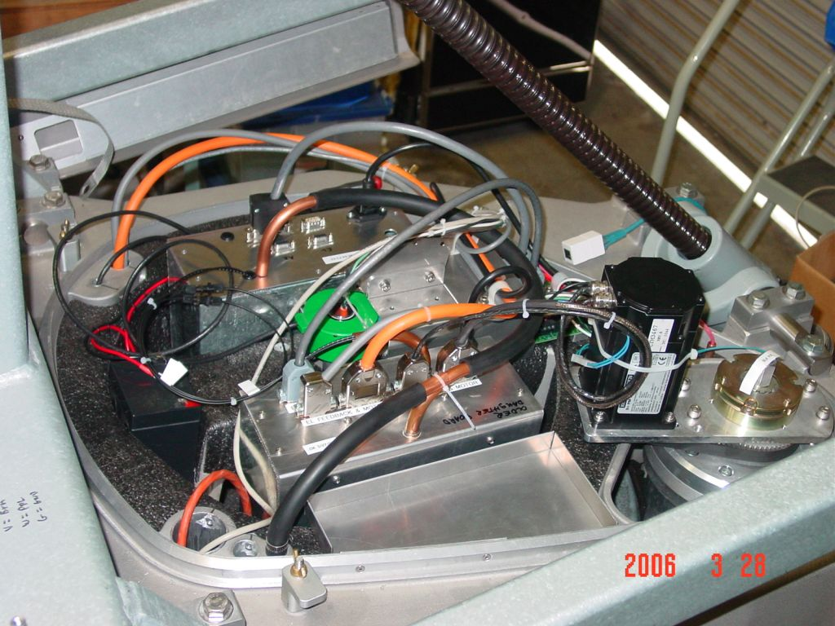
1
2
3
4
5
Figure 1: The alidade compartment:
1 – azimuth encoder/relay board
2 – azimuth driver/motor
3 – driver box
4 – controller box
5 – battery
The wiring is detailed in alidadeWireHarness.xls and ELMCoverview.vsd. It is released as alidadeWiring_srnXX.pdf.

Air comes up from the pedestal into the compartment and is then funneled to several places:
1 – a conduit takes most of the air to the front end (red arrow)
2 – snorkels on the controller box take in air, which is then vented to the outside (yellow)
3 – snorkels on the driver box take in air, which is then vented to the outside (yellow)
4 – conduit takes some air to the elevation “can” (green)
5 – conduit takes some air to the rim power box (blue)
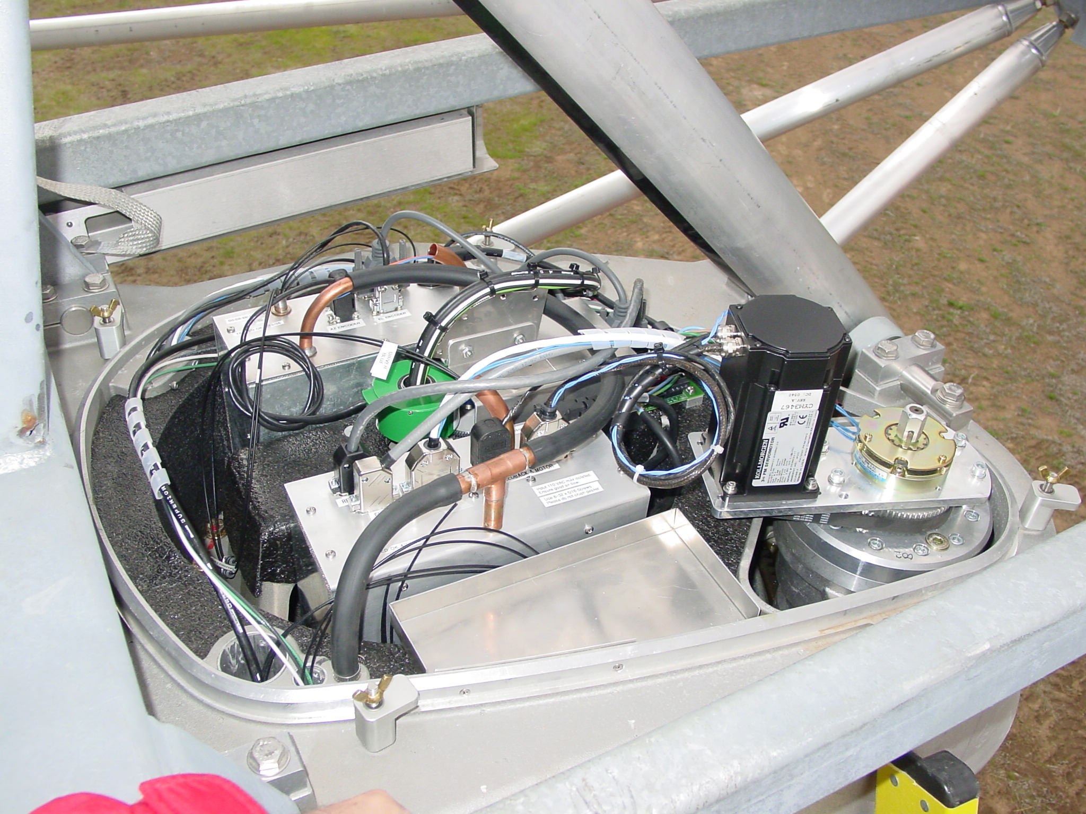
Figure 2
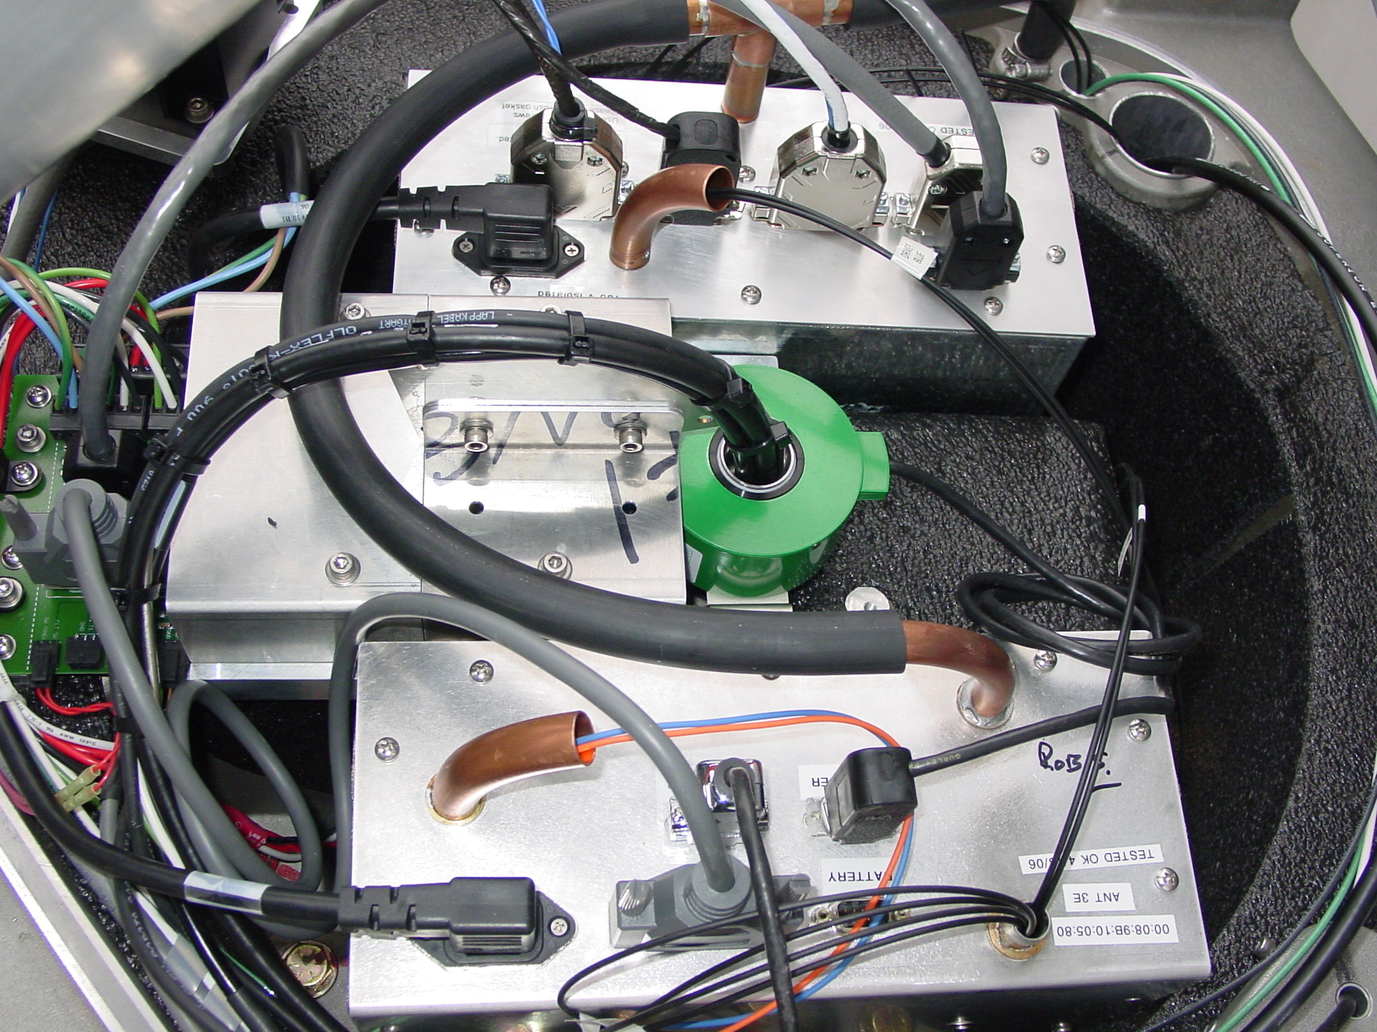
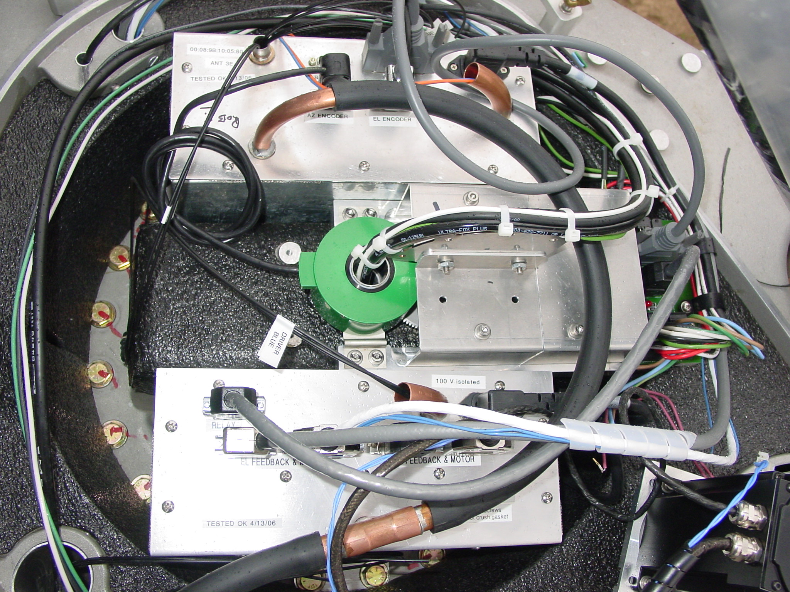
Figure 3
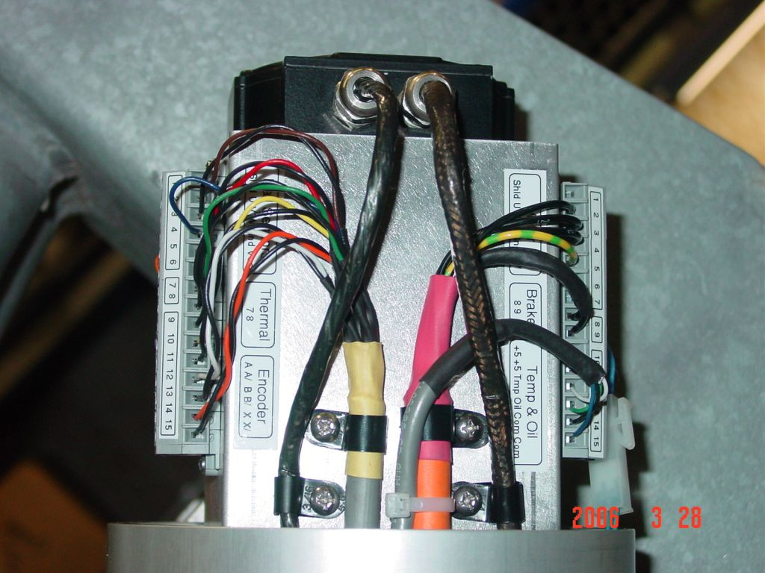
Figure 4

